PROCESS HAZARD ANALYSIS – WORKED EXAMPLE
PHA Study Report – Propane storage and propane–air dilution system
Integrated steel works (illustrative example)
Worked example for the Process Safety Analysis Toolkit: HAZID · What-If / Checklist · HAZOP · FMECA · Fault tree · Event tree · Bow tie
Item | Detail
Documents | HAZID HI-EX-PR-001 · What-If WI-EX-PR-001 · HAZOP HZ-EX-PR-001 · FMECA FM-EX-PR-001
Study dates | 2026-11-05 (HAZID) · 2026-11-05 (What-If) · 2026-11-09 to 2026-11-11 (HAZOP) · 2026-11-12 (FMECA)
Facilitator / scribe | A. Facilitator / B. Scribe (Istec)
Revision | A – worked example

Illustrative training example. The plant arrangement, tag numbers and failure data are representative of an LPG storage and propane–air installation at a steel works; they are not design data of any real plant and must not be used for decisions about one.

1 Purpose and how to use this example
This example shows one study carried through every tool of the Process Safety Analysis Toolkit: the HAZID screens the installation and picks the HAZOP nodes; the HAZOP finds the scenarios and the safeguards claimed; the FMECA looks at how the protective equipment fails; the fault trees quantify the protection layers; the event tree follows a release to its outcomes; the bow ties show the barriers to manage. Every file opens in its tool, and the numbers agree across them.
Key results: bullet overfill 1.9E-3 /yr (fault tree FT-PR-01, protection PFDavg 3.9E-3); flammable propane–air mixture 1.2E-2 /yr (FT-PR-02, protection PFDavg 1.8E-2); gas detection and ESD PFDavg 3.9E-2 (FT-PR-03); vapour cloud explosion or BLEVE 1.2E-5 /yr (ETA-PR-01); internal explosion of the mixing station 7.6E-5 /yr (BT-PR-02).
File (Examples / Propane Storage and Dilution PHA) | Open with | Content
Propane storage - HAZID_Register.xlsx | Excel | HAZID register – 20 hazards
Propane storage - What-If WI-EX-PR-001.whatif.json | What-If Checklist Analysis | What-If / Checklist – 3 areas, 23 questions
Propane storage - WhatIf_Checklist_Workbook.xlsx | Excel | The same What-If study in the workbook
Propane storage - HAZOP HZ-EX-PR-001.hazop.json | HAZOP Study Manager | 3 nodes, 32 deviations, 17 recommendations
Propane storage - HAZOP_Study_Workbook.xlsx / .xlsm | Excel | The same HAZOP in the workbook
Propane storage - FMECA_Workbook.xlsx / .xlsm | Excel | FMECA – 3 systems, 16 failure modes
Propane storage - FT-PR-01 Bullet overfill.fta.json | Fault Tree & PFD Calculator | FT-PR-01 – Storage bullet overfilled during unloading
Propane storage - FT-PR-02 Flammable propane-air mixture.fta.json | Fault Tree & PFD Calculator | FT-PR-02 – Propane–air mixture enters the flammable range
Propane storage - FT-PR-03 Gas detection and ESD.fta.json | Fault Tree & PFD Calculator | FT-PR-03 – Propane release at the unloading bay not isolated
Propane storage - ETA-PR-01 Major propane release.eta.json | Event Tree Analysis | ETA-PR-01 – Major propane release at the unloading bay or tank farm
Propane storage - BT-PR-01 Loss of containment.bowtie.json | Bow Tie Analysis | BT-PR-01 – Loss of containment of propane at the unloading bay and storage
Propane storage - BT-PR-02 Propane-air ignition.bowtie.json | Bow Tie Analysis | BT-PR-02 – Ignition of a propane–air mixture inside the dilution system

2 Source study and how this example was developed
The starting point is a published HAZOP case study of a propane storage and propane dilution system at a steel works. It lists three nodes – 301 road tanker to propane storage, 302 supply of propane to consumer, 303 propane dilution system – but its worksheet covers node 301 only: twelve deviations and two recommendations (earthing jumpers for static electricity, and a diesel generator for back-up power). The site is replaced by a fictional integrated steel works; the source tag numbers are kept.
Node 301 is reproduced with the source entries marked 'source', then completed and corrected. Nodes 302 and 303 are developed from good practice for LPG vaporisation and propane–air plants. Pressures in kg/cm² are converted to barg. The design data, set points and failure data are illustrative.

2.1 Gaps filled and corrections
# | Gap or weakness in the source | What this example does | Where
1 | Node 301 'Higher level – tank pressurisation': the consequence understates the hazard | Overfill sends liquid propane to the relief valves – a large two-phase release; quantified in a fault tree | N01-06, FT-PR-01, BT-PR-01 T1
2 | The level transmitter that gives the alarm also gives the trip – not independent | Modelled as a common-cause event; recommendation for an independent high-high switch | FT-PR-01 BE-004, R-004
3 | 'Lower temperature – no issue' | Auto-refrigeration of propane to −42 °C can cause brittle fracture of carbon steel | N01-08, R-007, BT-PR-01 T5
4 | No hose failure, tanker drive-away or vehicle impact | Added as deviations and bow-tie threats with an emergency release coupling and brake interlock | N01-09, N01-10, R-006
5 | Fire case stops at 'fire and explosion hazard' | BLEVE added as an event-tree end state with sprinkler cooling as a heading | N01-07, ETA-PR-01 H5, R-009
6 | Source remark 'PSV testing should be incorporated in the maintenance schedule' was not a recommendation | Made a recommendation with a test interval | N01-02, R-003
7 | Gas detectors at unspecified height | Propane vapour is heavier than air: detectors at low level; detection coverage modelled in the ESD fault tree | FT-PR-03 BE-005, R-008
8 | Nodes 302 and 303 have no worksheet | Developed: pumps, vaporisers, regulator; propane–air mixing with the flammable-mixture scenario as the key hazard | N02, N03, FT-PR-02, BT-PR-02

3 Scope and system description
Propane from the road-tanker connection at the unloading bay (node 301: unloading arm, vapour compressors C-01/C-02/C-03, liquid line via ROV-1 and inlet valves ROV-11/21/31 to the three storage bullets T-1/T-2/T-3), the liquid draw-off, pumps P-01/P-02, vaporisers VAP-01/VAP-02 and regulator PCV-01 to the 1.5 barg vapour header and the steel-works consumers (node 302), and the propane–air mixing station MX-01 with air blowers B-01/B-02, ratio control and surge tank ST-01 supplying propane–air to the reheat-furnace and ladle-preheater burners (node 303).
Design basis: Receive propane from 20 t road tankers (tanker design 20.6 barg) without overfilling or overpressuring the bullets (design 17.5 barg, design minimum temperature −45 °C, maximum fill 85 % of volume); vaporise propane and deliver vapour at 1.5 barg; blend it with air to a propane–air mixture of about 55 % propane (well above the upper flammable limit of 9.5 %) at 0.8 barg. Source pressures in kg/cm² are converted to barg. All values are illustrative.
Exclusions: Road tanker itself (owned by the supplier); burner internals and burner management at the users; fire-water pump house; electrical substation. Propane deliveries on public roads.
Node | Name | Design intent | Design / operating parameters
N01 | Node 301 – Road tanker unloading to propane storage T-1/T-2/T-3 | Transfer liquid propane from a 20 t road tanker into one storage bullet at a time by vapour compression, without overfilling, overpressure or release | Bullets T-1/T-2/T-3: 3 x 60 m3, design 17.5 barg, design min. temperature −45 °C, PSV-11/21/31 at 17.5 barg; tanker design 20.6 barg (source: 21 kg/cm2); compressor trip at 20.6 barg; maximum fill 85 % (LT-11/21/31 LAH 80 %, LAHH 85 % → closes ROV-11/21/31)  Operating: Unloading 60–90 min per delivery, about 150 deliveries a year; storage 5–12 barg depending on ambient temperature
N02 | Node 302 – Supply of propane to consumers (pumps, vaporisers, PCV-01) | Draw liquid propane from storage, vaporise it completely and deliver dry vapour at 1.5 barg to the users and the mixing station | Liquid lines 25 barg design; vaporisers 25 barg (liquid side), PSV-02 at 20 barg; vapour header 3.5 barg design; PSV-03 at 3.0 barg; TSL-01 low vapour outlet temperature trip at 10 °C; LSH-01 high liquid level in vaporiser trip  Operating: Liquid 8–12 barg; vapour 1.4–1.6 barg, 20–40 °C; up to 1 200 kg/h propane
N03 | Node 303 – Propane dilution system (propane–air mixing station) | Blend propane vapour with air to a propane–air mixture of 55 % propane (Wobbe index matched to natural gas, above the upper flammable limit) at 0.8 barg, and never let the mixture approach the flammable range | Mixer and surge tank ST-01 3.5 barg design, PSV-04 at 2.0 barg; explosion vent panel EP-01 on ST-01; flame arrester FA-01 on the propane–air header; PSLL-01 low propane pressure trip stops B-01/B-02 and closes XV-01/XV-02  Operating: Propane–air 0.8 barg, 50–60 % propane, 300–2 500 Nm3/h

3.1 Risk criteria
All studies use the toolkit's 5 x 5 risk matrix: risk = severity (1–5) x likelihood (1–5); Low < 5, Medium 5–9, High 10–19, Very High ≥ 20. Likelihood bands: 1 < 1E-4 /yr, 2 1E-4–1E-3, 3 1E-3–1E-2, 4 1E-2–0.1, 5 > 0.1 /yr. Event-tree and bow-tie targets: catastrophic outcomes ≤ 1E-4 /yr, major ≤ 1E-2 /yr.

3.2 Team and sessions
Name | Company / department | Role | Attendance
A. Facilitator | Istec | Facilitator | Days 1–3
B. Scribe | Istec | Scribe | Days 1–3
C. Process | Utilities | Process engineer | Days 1–3
D. Operator | Utilities | LPG plant operator | Days 1–3
E. Instrument | Maintenance | Instrument / control engineer | Days 1–3
F. Mechanical | Maintenance | Mechanical engineer | Days 1–2
G. Safety | HSE | HSE / process safety | Days 1–3
H. Furnace | Rolling mill | Furnace operations representative | Day 3
I. Supplier | LPG supplier | Tanker operations representative | Day 1

Date | Nodes | Notes
2026-11-09 | N01 | Node 301 (tanker to storage) – source worksheet reviewed, completed and corrected; overfill referred to FT-PR-01, releases to BT-PR-01 / ETA-PR-01.
2026-11-10 | N02 | Node 302 (supply to consumers) – pumps, vaporisers, regulator.
2026-11-11 | N03 | Node 303 (propane dilution) – flammable-mixture scenario referred to FT-PR-02 and BT-PR-02. Study closed; FMECA on 12 Nov.

4 HAZID and What-If / Checklist

4.1 HAZID register
Structured brainstorm with the HAZID guidewords; S x L on the toolkit's 5 x 5 risk matrix; every High / Very High item sent to a HAZOP node or a quantified study. The whole LPG installation: unloading bay, tank farm, pump and vaporiser area, mixing station and the propane–air header to the furnace building, including traffic, utilities, maintenance and emergency response.
ID | Area | Guideword | Hazard | Cause / threat | Consequence | Existing safeguards | S x L | Further study | Rec.
HZD-01 | Unloading bay | Fire and explosion | Liquid propane release during unloading | Hose / arm failure, coupling error, drive-away | Flash fire, jet fire, VCE; BLEVE of the tanker | Hose inspection, gas detection, ESD, sprinklers | 5 x 3 = 15 High | HAZOP N01-09, N01-10; FT-PR-03; ETA-PR-01; BT-PR-01 T2, T3 | R-006, R-008
HZD-02 | Tank farm | Fire and explosion | Bullet overfilled during unloading | Ullage not checked; level gauge reads low; trip shares the gauge | Liquid relief through PSV-11/21/31 – large release | LAH, LAHH trip on the same transmitter, procedure | 5 x 4 = 20 Very High | HAZOP N01-06; FT-PR-01; BT-PR-01 T1 | R-004, R-005
HZD-03 | Tank farm | Fire and explosion | BLEVE of a bullet in a fire | Jet or pool fire impinging on the vapour space | Fireball, fragments up to several hundred metres | Relief valves, sprinklers, separation | 5 x 2 = 10 High | HAZOP N01-07; ETA-PR-01 H5; BT-PR-01 | R-009
HZD-04 | Tank farm | Pressure | Bullet overpressure in hot weather | Vapour pressure about 16 barg at 50 °C | Relief valve lifts – propane vapour vented | Design 17.5 barg, PSV-11/21/31 | 3 x 3 = 9 Medium | HAZOP N01-04 | R-003
HZD-05 | Unloading bay / tank farm | Temperature (low) | Brittle fracture after auto-refrigeration | Rapid depressurisation or flashing liquid leak (−42 °C) | Sudden failure of a pressurised line or vessel | Low-temperature carbon steel (to be verified) | 5 x 2 = 10 High | HAZOP N01-08; BT-PR-01 T5 | R-007
HZD-06 | Unloading bay | Static electricity | Static discharge during filling | High flow; unbonded flanges; tanker not earthed | Ignition of a small leak | Earthing of line, tanker and tanks | 4 x 3 = 12 High | HAZOP N01-03 | R-001
HZD-07 | Unloading bay | Transport / vehicles | Vehicle impact on the arm or bullets | Other traffic during unloading; reversing tanker | Release; escalation | Kerbs only | 5 x 2 = 10 High | HAZOP N01-01; BT-PR-01 T6 | R-016
HZD-08 | Unloading bay | Human factors | Cold burns when connecting / disconnecting | Liquid propane spray from couplings | Frostbite to hands and face | Gloves | 3 x 3 = 9 Medium | BT-PR-01 consequence COLD
HZD-09 | Pump and vaporiser area | Fire and explosion | Pump seal leak | Dry running, wear | Liquid propane release and fire near the bullets | Single seals, gas detection | 5 x 3 = 15 High | HAZOP N02-02, N02-08; BT-PR-01 T4 | R-010
HZD-10 | Pump and vaporiser area | Process upset | Liquid carry-over from the vaporisers | Bath heater failure, flow above capacity | Liquid in the vapour header – burner flare-ups | TSL-01 trip | 4 x 3 = 12 High | HAZOP N02-04, N02-05 | R-011
HZD-11 | Vapour header | Pressure | Vapour header overpressure | PCV-01 fails open | Leaks at users' fuel trains | SSV-01, PSV-03 | 4 x 3 = 12 High | HAZOP N02-03 | R-012
HZD-12 | Mixing station | Fire and explosion | Propane–air mixture in the flammable range | Loss of propane while the blowers run; ratio controller fault | Internal explosion of ST-01 and the header | PSLL-01 trip, AT-01 (not independent), FA-01 | 5 x 4 = 20 Very High | HAZOP N03-01, N03-02; FT-PR-02; BT-PR-02 T1 | R-013
HZD-13 | Mixing station | Start-up / shutdown | Start-up with air in the system | Purge omitted; blowers started first | Explosion at the first light-off | Procedure OP-PR-020 | 5 x 3 = 15 High | HAZOP N03-06; BT-PR-02 T2 | R-014
HZD-14 | Furnace building | Fire and explosion | Flashback from the burners | Low header pressure; mixture near the flammable range | Deflagration in the header | FA-01, users' BMS | 5 x 2 = 10 High | HAZOP N03-07; BT-PR-02 T3 | R-015
HZD-15 | Whole installation | Utilities | Power failure | Grid failure | Loss of supply; ESD and gas detection on UPS only | Fail-closed ROVs, UPS-1 | 3 x 3 = 9 Medium | HAZOP N01-12, N02-10, N03-09 | R-002
HZD-16 | Whole installation | Maintenance | Opening equipment with propane inside | Single-valve isolation, trapped liquid | Flash fire, cold burns | Permit-to-work | 4 x 3 = 12 High | HAZOP N01-13
HZD-17 | Whole installation | Natural events | Lightning strike | Thunderstorms (summer) | Ignition at a relief valve outlet | Lightning protection, earthing | 4 x 2 = 8 Medium | –
HZD-18 | Whole installation | Security | Unauthorised access / tampering | Open site perimeter at the bay | Valves opened, release | Fenced compound, locked valves | 4 x 2 = 8 Medium | –
HZD-19 | Whole installation | Emergency response | Fire brigade response to an LPG fire | Inexperience with BLEVE risk | Fire fighters exposed to a BLEVE | Emergency plan | 5 x 2 = 10 High | ETA-PR-01; BT-PR-01 | R-017
HZD-20 | Whole installation | Environment | Propane venting to atmosphere | Relief valve lifts, maintenance venting | VOC emission; odour complaints | Vent to a safe location | 2 x 3 = 6 Medium | –

4.2 What-If / Checklist analysis
Method: combined What-If / Checklist analysis (CCPS, Guidelines for Hazard Evaluation Procedures, 3rd ed., section 5.2), study WI-EX-PR-001, 2026-11-05. It follows the HAZID HI-EX-PR-001 and prepares the HAZOP HZ-EX-PR-001: the team listed What-If questions for each area or task, used the checklist to cover any gaps, and then decided for each question whether it is closed at What-If level, sent to a HAZOP node, or sent to a quantified study.
Three parts of the installation that the HAZID ranked High: the road-tanker unloading task (step by step), the bullet storage area, and the vaporisation and propane–air mixing system. Questions that need a systematic deviation analysis are sent to HAZOP nodes N01–N03.
No. | Area / function / task | Type | Checklist packs | Checklist answered | Gaps (No / ?) | What-Ifs | Feeds HAZOP
A01 | Road-tanker unloading – arrival to departure | Task / procedure | GEN, LPG | 9 | 5 | 8 | N01
A02 | Bullet storage area T-1 / T-2 / T-3 | Physical area | GEN, LPG | 9 | 4 | 7 | N01
A03 | Vaporisation and propane–air mixing | Function / system | GEN, LPG | 7 | 2 | 8 | N02, N03

Checklist gaps (answered No or ?) and the What-If question each raised:
Area | Item | Checklist question | Answer | Note | What-If
A01 | GEN-MAT-03 | Is the identity of incoming raw materials checked before they are unloaded? | No | Product identity taken on trust from the delivery note | A01-01
A01 | LPG-OPS-03 | Is the tanker immobilised (brake interlock, wheel chocks, key control) during transfer? | ? | Brake interlock fitted; key control not written | A01-03
A01 | LPG-OPS-04 | Is the unloading attended for the whole transfer? | No | Operator often leaves for other duties | A01-05
A01 | LPG-EQP-02 | Are unloading hoses inspected, pressure tested and replaced on time? | ? | Test records not found | A01-04
A01 | LPG-MAT-01 | Is the cold of flashing LPG (down to about −42 °C for propane) considered for people and steel? | ? | No cold-burn PPE at the bay | A01-07
A02 | LPG-REL-02 | Is the vessel protected against BLEVE (water spray / deluge, insulation, mounding)? | ? | Sprinkler test two years ago | A02-01
A02 | GEN-LAY-03 | Is equipment protected from vehicle impact? | No | No barriers at the pipework | A02-03
A02 | LPG-MAT-02 | Is it known that LPG vapour is heavier than air and collects in low places? | ? | Drain pit 6 m from T-3 | A02-04
A02 | GEN-EMR-07 | Are the local emergency services informed of the hazards? | No | Brigade not briefed | A02-06
A03 | GEN-SSD-02 | Is equipment purged of air or process material before start-up or maintenance? | ? | Purge by procedure only | A03-05
A03 | GEN-INS-03 | Is trip bypassing controlled by permit and time limit? | No | No bypass register | A03-08

What-If worksheet – A01 Road-tanker unloading – arrival to departure (task / procedure)
Ref | What if…? | Consequence | Safeguards | Risk before | Recommendation | Risk after | Next step
A01-01 | What if the tanker delivers butane-rich or off-specification product? | Vapour pressure differs from design; vaporisers and burners upset | • Supplier contract specification | 3 x 2 = 6 | WR-01 Check the delivery note and take a vapour-pressure sample of each new supplier's product before first unloading. | 3 x 1 = 3 | Closed at What-If
A01-02 | What if transfer starts before the tanker is earthed? | Spark ignites a propane release at the coupling | • EBI-1 – Earth bonding interlock  • Unloading procedure OP-PR-010 | 4 x 3 = 12 |  | 4 x 2 = 8 | Send to HAZOP → N01-03
A01-03 | What if the tanker drives off while still connected? | Arm torn off – large liquid propane release | • ERC-1 – Emergency release coupling [IPL]  • Tanker brake interlock and wheel chocks | 5 x 3 = 15 | WR-02 Write tanker key control into OP-PR-010: the operator holds the ignition key from earthing until disconnection. | 5 x 1 = 5 | Send to HAZOP → N01-10
A01-04 | What if the hose or unloading arm fails during transfer? | Two-phase release at the bay; jet fire or flash fire if ignited | • GLD-1/2/3 – Gas detection with ESD [IPL]  • ERC-1 – Emergency release coupling [IPL] | 5 x 3 = 15 | WR-03 Set up a hose and arm register with test dates; no transfer with a hose whose test is out of date. | 5 x 2 = 10 | Send to quantified study (FT / ETA / bow tie) → ETA-PR-01
A01-05 | What if the unloading is left unattended? | Overfill or a leak goes unnoticed; release grows | • LT-11 – High level alarm LAH | 4 x 3 = 12 | WR-04 Make continuous attendance mandatory during transfer and add a dead-man button on the unloading panel. | 4 x 2 = 8 | Closed at What-If
A01-06 | What if the ullage check before unloading is skipped or wrong? | Bullet overfilled – liquid to the relief valve | • LT-11 – High level alarm LAH and operator [IPL]  • LT-11 – High-high level trip closes ROV-11 [IPL] | 5 x 3 = 15 |  | 5 x 2 = 10 | Send to quantified study (FT / ETA / bow tie) → FT-PR-01
A01-07 | What if cold liquid sprays on the operator at disconnection? | Cold burns to hands and face | • Gloves and safety glasses | 3 x 3 = 9 | WR-05 Issue cold-resistant gloves and face shields at the unloading bay; depressurise the arm to the vapour line before disconnection. | 3 x 2 = 6 | Closed at What-If
A01-08 | What if the vapour compressor runs against a closed ROV-1? | High pressure in the tanker vapour space | • C-01/C-02/C-03 – Discharge high-pressure trip | 3 x 3 = 9 |  | 3 x 2 = 6 | Send to HAZOP → N01-02

What-If worksheet – A02 Bullet storage area T-1 / T-2 / T-3 (physical area)
Ref | What if…? | Consequence | Safeguards | Risk before | Recommendation | Risk after | Next step
A02-01 | What if a jet fire from a flange impinges on a bullet and the sprinklers do not start? | BLEVE – fireball and fragments | • PSV-11 – Fire-case relief valves [IPL]  • Water sprinklers on the bullets | 5 x 2 = 10 | WR-06 Test the bullet sprinklers annually with a flow test and record the coverage. | 5 x 1 = 5 | Send to quantified study (FT / ETA / bow tie) → ETA-PR-01
A02-02 | What if a bullet is emptied quickly by venting and the steel gets very cold? | Brittle fracture – sudden release | • Low-temperature carbon steel [IPL]  • Depressurisation procedure | 5 x 2 = 10 |  | 5 x 1 = 5 | Send to HAZOP → N01-08
A02-03 | What if a vehicle hits the bullet pipework? | Pipe break – liquid release | • ROV-11 – Fails closed on ESD | 4 x 3 = 12 | WR-07 Install crash barriers around the bullet pipework and the unloading arm. | 4 x 1 = 4 | Closed at What-If
A02-04 | What if propane vapour collects in the drain pit next to the bullets? | Flash fire or explosion in the pit | • GLD-1/2/3 – Gas detection | 4 x 3 = 12 | WR-08 Seal the drain pit next to the bullets or fit it with a water seal and a low-level gas detector. | 4 x 1 = 4 | Closed at What-If
A02-05 | What if a bullet is opened for inspection with propane still inside? | Release and fire during maintenance | • Permit-to-work with N2 purge and gas test | 4 x 3 = 12 |  | 4 x 2 = 8 | Send to HAZOP → N01-13
A02-06 | What if the fire brigade arrives and does not know the LPG hazards? | Wrong tactics; responders inside the BLEVE zone | • Site emergency response team | 5 x 2 = 10 | WR-09 Prepare an LPG pre-incident plan with the municipal fire brigade and exercise it yearly. | 5 x 1 = 5 | Closed at What-If
A02-07 | What if lightning strikes during unloading? | Small fire at a relief outlet | • Lightning protection of the bullets  • Unloading stopped during storms (OP-PR-010) | 3 x 2 = 6 |  | 2 x 2 = 4 | Closed at What-If

What-If worksheet – A03 Vaporisation and propane–air mixing (function / system)
Ref | What if…? | Consequence | Safeguards | Risk before | Recommendation | Risk after | Next step
A03-01 | What if a pump seal leaks at night when no one is in the area? | Vapour cloud at the pump bay; fire if ignited | • P-01/P-02 – Double mechanical seals with seal-pot alarm  • GLD-1/2/3 – Gas detection | 4 x 3 = 12 |  | 4 x 2 = 8 | Send to HAZOP → N02-08
A03-02 | What if a vaporiser loses its heating while demand is high? | Liquid propane reaches PCV-01 and the users | • TSL-01 – Low vapour temperature trip [IPL]  • LSH-01 – High liquid level trip [IPL] | 4 x 3 = 12 |  | 4 x 2 = 8 | Send to HAZOP → N02-04
A03-03 | What if the regulator PCV-01 fails open? | Header overpressure – leak at flanges and users | • SSV-01 – Slam-shut valve [IPL]  • PSV-03 – Vapour header relief valve [IPL] | 4 x 3 = 12 |  | 4 x 1 = 4 | Send to HAZOP → N02-03
A03-04 | What if the air blowers keep running when the propane supply is lost? | Mixture enters the flammable range – explosion in MX-01 or the header | • PSLL-01 – Low propane pressure trip [IPL]  • AT-01 – Calorimeter trip [IPL] | 5 x 3 = 15 |  | 5 x 2 = 10 | Send to quantified study (FT / ETA / bow tie) → FT-PR-02
A03-05 | What if the mixing station is started with air still in the mixer and surge tank? | Flammable mixture at first propane admission | • Start-up procedure OP-PR-020 with N2 purge | 5 x 3 = 15 | WR-10 Add an oxygen check (AT-01 reading) as a permissive before propane is admitted at start-up. | 5 x 1 = 5 | Send to HAZOP → N03-06
A03-06 | What if a burner flashes back into the propane–air header? | Explosion in the header | • FA-01 – In-line flame arrester [IPL] | 4 x 3 = 12 |  | 4 x 2 = 8 | Send to HAZOP → N03-07
A03-07 | What if power fails at the mixing station? | Uncontrolled mixture on restart | • UPS-1 – UPS for controls and gas detection  • Fail-closed valves XV-01/XV-02 | 3 x 3 = 9 |  | 3 x 2 = 6 | Send to HAZOP → N03-09
A03-08 | What if the mixture trips are left in bypass after the annual trip test? | Flammable mixture not stopped | • Annual proof test of the mixture trips | 5 x 2 = 10 | WR-11 Introduce a trip-bypass register with time limits and shift sign-off. | 5 x 1 = 5 | Closed at What-If

Outcome: 8 questions closed at What-If level, 11 sent to the HAZOP, 4 sent to quantified studies, 0 need further information. 11 What-If recommendations (WR-xx) are tracked with the HAZOP recommendations.
HAZID | Hazard | S x L | Examined in What-If | Sent on to
HZD-01 | Liquid propane release during unloading | 5 x 3 | A01-03, A01-04, A02-04 | N01-10, ETA-PR-01
HZD-02 | Bullet overfilled during unloading | 5 x 4 | A01-05, A01-06 | FT-PR-01
HZD-03 | BLEVE of a bullet in a fire | 5 x 2 | A02-01 | ETA-PR-01
HZD-05 | Brittle fracture after auto-refrigeration | 5 x 2 | A02-02 | N01-08
HZD-06 | Static discharge during filling | 4 x 3 | A01-02 | N01-03
HZD-07 | Vehicle impact on the arm or bullets | 5 x 2 | A01-03, A02-03 | N01-10
HZD-09 | Pump seal leak | 5 x 3 | A03-01 | N02-08
HZD-10 | Liquid carry-over from the vaporisers | 4 x 3 | A03-02 | N02-04
HZD-11 | Vapour header overpressure | 4 x 3 | A03-03 | N02-03
HZD-12 | Propane–air mixture in the flammable range | 5 x 4 | A03-04, A03-08 | FT-PR-02
HZD-13 | Start-up with air in the system | 5 x 3 | A03-05 | N03-06
HZD-14 | Flashback from the burners | 5 x 2 | A03-06 | N03-07
HZD-16 | Opening equipment with propane inside | 4 x 3 | A02-05 | N01-13
HZD-19 | Fire brigade response to an LPG fire | 5 x 2 | A02-06

5 HAZOP results
Node | Name | Deviations | Highest risk before | Highest risk after | Recommendations
N01 | Node 301 – Road tanker unloading to propane storage T-1/T-2/T-3 | 13 | 20 | 15 | R-001, R-002, R-003, R-004, R-005, R-006, R-007, R-008, R-009, R-016, R-017
N02 | Node 302 – Supply of propane to consumers (pumps, vaporisers, PCV-01) | 10 | 15 | 10 | R-002, R-005, R-008, R-010, R-011, R-012
N03 | Node 303 – Propane dilution system (propane–air mixing station) | 9 | 20 | 20 | R-002, R-008, R-013, R-014, R-015

5.1 HAZOP worksheets

N01 – Node 301 – Road tanker unloading to propane storage T-1/T-2/T-3
Ref | Deviation | Causes | Consequences / comments | Safeguards | Risk before | Risk after | Rec.
N01-01 | Flow / NO  No / less flow – compressor malfunction | • Compressor C-01/C-02/C-03 trip or malfunction (source)  • Vapour return valve closed | Low or no filling rate into the storage tank (source); longer tanker stay at the bay increases the exposure time for drive-away and traffic impact  Source deviation 'No / less flow – compressor malfunction'. | • C-01/C-02/C-03 – Standby vapour compressor available (source) | 2 x 4 = 8 | 2 x 3 = 6 | R-016
N01-02 | Flow / NO  No flow – ROV-1 stuck closed while the compressor runs | • ROV-1 stuck closed (source)  • Tank inlet ROV-11/21/31 closed (wrong tank selected or trip) | No filling of the storage tank; pressure rises in the tanker as the compressor keeps pushing vapour (source) – tanker relief valve may lift at the bay  Source safeguards: compressor trip at 21 kg/cm2 (20.6 barg), tanker designed for 21 kg/cm2, pressure gauge and tanker PSV. Source remark: include PSV testing in the maintenance schedule (R-003). | • C-01/C-02/C-03 – Compressor discharge high-pressure trip at 20.6 barg (source: 21 kg/cm2)  • Tanker designed for 20.6 barg; bullets designed for 17.5 barg (source) [IPL]  • PG-01 – Pressure gauges PG-01, PG-12, PG-13, PG-14 on the unloading header and bullets; tanker pressure gauge (source) | 4 x 3 = 12 | 4 x 2 = 8 | R-003
N01-03 | Flow / MORE  More flow – high pressure difference between tanker and tank | • More pressure difference in tanker and tank (source)  • Compressor run at full speed on a near-empty tank | Static charge generated in the line during liquid filling (source); spark discharge at an unbonded flange can ignite a small leak  Source recommendation no. 1 (earthing jumpers at every flange) is R-001. | • EBI-1 – Tanker, line and tanks earthed; earth bonding interlock EBI-1 prevents compressor start without a verified tanker earth  • Ignition source control – Ex equipment in zoned areas, hot-work permits, vehicle control, no mobile phones at the bay | 4 x 3 = 12 | 4 x 2 = 8 | R-001
N01-04 | Pressure / MORE  Higher pressure in the bullet during unloading | • Tank inlet closed while the compressor delivers vapour to the tanker side  • Hot weather – vapour pressure 16 barg at 50 °C  • Liquid overfill – no vapour space left (see N01-06) | Bullet pressure towards the 17.5 barg relief setting; PSV-11/21/31 lift and vent propane vapour; flammable cloud at the tank farm | • PSV-11/21/31 – Bullet relief valves PSV-11/21/31 at 17.5 barg, fire-case sized, discharging vertically upwards (source: 'PSV provided') [IPL]  • PG-01 – Pressure gauges PG-01, PG-12, PG-13, PG-14 on the unloading header and bullets; tanker pressure gauge (source)  • C-01/C-02/C-03 – Compressor discharge high-pressure trip at 20.6 barg (source: 21 kg/cm2) | 4 x 3 = 12 | 4 x 2 = 8 | R-003
N01-05 | Pressure / LESS  Lower pressure | • Covered in less flow (source)  • Vapour drawn off faster than the liquid vaporises in winter | No hazard to the bullets – propane vapour pressure stays above atmospheric down to −42 °C; slower unloading only  Source entry 'covered in less flow'. | • C-01/C-02/C-03 – Standby vapour compressor available (source) | 1 x 3 = 3 | 1 x 3 = 3
N01-06 | Level / MORE  Higher level in storage tank T-1/T-2/T-3 (overfill) | • Transfer not stopped at high level (source)  • Wrong ullage – delivery larger than the free volume  • Level transmitter LT-11/21/31 reads low (drift, stuck float) | Source: tank pressurisation. Correctly: the bullet fills liquid-full; liquid propane reaches the relief valves – liquid relief and a large two-phase release at the tank farm; hydraulic overpressure of the liquid-full bullet as it warms  The source credited only the LT closing the ROV, whose transmitter is also the gauge the operator uses – not independent. Quantified in fault tree FT-PR-01 (top 1.9E-3 /yr); overfill is threat T1 of bow tie BT-PR-01. Likelihood after safeguards from the calculated frequency 1.9E-3 /yr. | • LT-11/21/31 – High-high level trip LAHH (85 %) from LT-11/21/31 closes ROV-11/21/31 and stops the compressors (source: LT closes ROV) [IPL]  • LT-11/21/31 – High level alarm LAH at 80 % with operator response (stop unloading) [IPL]  • Tanker unloading procedure OP-PR-010 and checklist: ullage check before unloading, operator in attendance throughout  • PSV-11/21/31 – Bullet relief valves PSV-11/21/31 at 17.5 barg, fire-case sized, discharging vertically upwards (source: 'PSV provided') | 5 x 4 = 20 | 5 x 3 = 15 | R-004, R-005
N01-07 | Temperature / MORE  Higher temperature – external fire | • External fire (source)  • Pool fire from a release at the unloading bay | Fire and explosion hazard; high pressure (source); flame impingement on the vapour space of a bullet or tanker weakens the shell – BLEVE with fireball and fragments  Source safeguards: PRV-01, gauges, gas detectors GLD-1/2/3, water sprinklers for the tanks and the unloading station, PSV. BLEVE is an end state of event tree ETA-PR-01. | • PSV-11/21/31 – Bullet relief valves PSV-11/21/31 at 17.5 barg, fire-case sized, discharging vertically upwards (source: 'PSV provided') [IPL]  • PRV-01 – Thermal relief valve PRV-01 on the unloading liquid line (source)  • GLD-1/2/3 – Gas leak detectors GLD-1, GLD-2, GLD-3 at the unloading bay and tank farm with alarm (source)  • Water sprinklers on the bullets and the tanker unloading station (source), 10 l/min/m2  • ESD-1 – Manual ESD push buttons at the unloading bay, tank farm and control room  • Emergency response team and fire brigade; LPG emergency plan (cooling, evacuation radius) | 5 x 2 = 10 | 5 x 1 = 5 | R-009, R-017
N01-08 | Temperature / LESS  Lower temperature – auto-refrigeration | • Rapid depressurisation / venting of liquid propane (auto-refrigeration to −42 °C)  • Liquid leak through a valve – flashing liquid chills the line | Source: 'no issue'. Correctly: carbon steel below its minimum design temperature becomes brittle; a pressurised bullet or line can fail by brittle fracture – sudden large release; cold burns to operators  Corrected source entry. Brittle fracture is threat T5 of bow tie BT-PR-01. | • Bullets and liquid lines in low-temperature carbon steel (design min. −45 °C) [IPL]  • Depressurisation procedure: no rapid venting of liquid-full equipment; vent only vapour to the flare stack | 5 x 2 = 10 | 5 x 1 = 5 | R-007
N01-09 | Flow / AS WELL AS  Release during transfer – hose / arm failure | • Unloading arm or hose failure (wear, kinking, wrong gasket)  • Coupling not fully engaged | Liquid propane release at the unloading bay at up to 10 barg; large flammable cloud (heavier than air); jet fire if ignited; exposure of the tanker  Not in the source worksheet. Threat T2 of bow tie BT-PR-01; isolation by fault tree FT-PR-03. | • Unloading arm / hose inspection and annual pressure test; leak test before each transfer  • UCP-1 – Gas detection GLD-1/2/3 (1oo3) and manual ESD ESD-1 close ROV-1 and ROV-11/21/31 and stop C-01/C-02/C-03 (logic UCP-1) [IPL]  • GLD-1/2/3 – Gas leak detectors GLD-1, GLD-2, GLD-3 at the unloading bay and tank farm with alarm (source)  • Ignition source control – Ex equipment in zoned areas, hot-work permits, vehicle control, no mobile phones at the bay | 5 x 3 = 15 | 5 x 2 = 10 | R-008
N01-10 | Flow / REVERSE  Tanker drive-away while still connected | • Driver moves the tanker before disconnection  • Brakes not applied / chocks missing | Arm or hose pulled apart – liquid release from both the tanker and the plant side; severe if the excess-flow valves do not close  Not in the source worksheet. Threat T3 of bow tie BT-PR-01. | • Tanker brake interlock and wheel chocks; keys held by the unloading operator  • ERC-1 – Emergency release coupling ERC-1 on the unloading arm with self-closing valves on both sides [IPL]  • Tanker unloading procedure OP-PR-010 and checklist: ullage check before unloading, operator in attendance throughout | 5 x 3 = 15 | 5 x 2 = 10 | R-006
N01-11 | Composition / AS WELL AS  Impurity / concentration | • NA (source)  • Water in the delivered propane  • Butane-rich delivery (wrong grade) | Source: not applicable. Water can freeze in regulators and drains; butane raises the dew point – liquid in the vapour header (see N02)  Source entries 'Concentration – NA' and 'Impurity – NA' reviewed: a delivery-quality check was added to the checklist. | • Tanker unloading procedure OP-PR-010 and checklist: ullage check before unloading, operator in attendance throughout | 2 x 3 = 6 | 2 x 2 = 4 | R-005
N01-12 | Utilities / services / LOSS OF  Utility failure – power | • Power failure (source)  • Instrument air failure | No transfer of propane from tanker to storage tank; compressors C-01/C-02/C-03 stop (source). All ROVs and SVs close (source) – safe state, but the gas detection and ESD are lost if the UPS fails  Source recommendation no. 2 (diesel generator for back-up power) is R-002. | • ROV-1 – All ROVs and solenoid valves fail closed on loss of power or air (source) [IPL]  • UPS-1 – UPS for UCP-1 and the gas detection (30 min); ROVs fail closed | 3 x 3 = 9 | 3 x 2 = 6 | R-002
N01-13 | Maintenance / INADEQUATE  Maintenance – opening equipment that still contains propane | • Isolation by a single valve; liquid trapped between valves  • Purge not complete before hot work | Propane release at the point of work; flash fire; cold burns | • Permit-to-work with isolation verification, N2 purge / gas-free test and fire watch  • Ignition source control – Ex equipment in zoned areas, hot-work permits, vehicle control, no mobile phones at the bay | 4 x 3 = 12 | 4 x 2 = 8

N02 – Node 302 – Supply of propane to consumers (pumps, vaporisers, PCV-01)
Ref | Deviation | Causes | Consequences / comments | Safeguards | Risk before | Risk after | Rec.
N02-01 | Flow / NO  No liquid flow to the vaporisers | • Pump P-01/P-02 trip  • Bullet outlet valve ROV-12/22/32 closed  • Bullet empty / low level | Loss of propane vapour to the users and the mixing station; burners trip on low pressure; at the mixer, air may continue – see N03-01 | • P-01/P-02 – Pump minimum-flow recycle and low-suction-pressure trip  • PT-02 – Vapour header pressure alarms PAH / PAL on PT-02 with operator response  • Low-low fuel pressure trips in the users' burner management systems [IPL] | 3 x 4 = 12 | 3 x 3 = 9
N02-02 | Flow / LESS  Pump cavitation / loss of suction | • Low liquid level in the bullet  • Strainer blocked  • High liquid temperature (summer) – low NPSH margin | Pump dry running – seal failure and liquid propane leak at the pump | • P-01/P-02 – Pump minimum-flow recycle and low-suction-pressure trip  • P-01/P-02 – Double mechanical seals with seal-pot pressure alarm on P-01/P-02  • GLD-1/2/3 – Gas leak detectors GLD-1, GLD-2, GLD-3 at the unloading bay and tank farm with alarm (source) | 4 x 3 = 12 | 4 x 2 = 8 | R-010
N02-03 | Pressure / MORE  Higher pressure in the vapour header | • PCV-01 fails open  • Regulator sensing line blocked  • Vaporiser over-heating raises the pressure upstream | Vapour header (3.5 barg design) and users' fuel trains over-pressured – flange leaks, burner over-firing | • SSV-01 – Slam-shut valve SSV-01 upstream of PCV-01 closes at 2.5 barg (over-pressure shut-off) [IPL]  • PSV-03 – Vapour header relief valve PSV-03 at 3.0 barg to a safe location [IPL]  • PT-02 – Vapour header pressure alarms PAH / PAL on PT-02 with operator response | 4 x 3 = 12 | 4 x 2 = 8 | R-012
N02-04 | Temperature / LESS  Low vapour temperature – liquid carry-over from the vaporiser | • Vaporiser bath heater failure  • Flow above the vaporiser capacity  • Bath water level low | Liquid propane carried into the vapour header; liquid at regulators and burners – flare-ups, over-firing, cold embrittlement of carbon-steel piping | • VAP-01/VAP-02 – Vaporiser bath temperature control with duty / standby vaporisers  • TSL-01 – Low vapour outlet temperature trip TSL-01 (10 °C) closes the vaporiser liquid inlet [IPL]  • LSH-01 – High liquid level trip LSH-01 in the vaporiser shell closes the liquid inlet (liquid carry-over protection) | 4 x 3 = 12 | 4 x 2 = 8 | R-011
N02-05 | Level / MORE  High liquid level in the vaporiser shell | • Inlet control valve fails open  • Vapour draw-off restricted | Liquid carry-over to the header (as N02-04) | • LSH-01 – High liquid level trip LSH-01 in the vaporiser shell closes the liquid inlet (liquid carry-over protection) [IPL]  • TSL-01 – Low vapour outlet temperature trip TSL-01 (10 °C) closes the vaporiser liquid inlet | 4 x 3 = 12 | 4 x 2 = 8 | R-011
N02-06 | Pressure / MORE  Vaporiser overpressure – liquid side | • Liquid blocked in between closed valves and heated (thermal expansion)  • Bath over-temperature | Rupture of the vaporiser tube bundle – propane into the water bath and its vent | • PSV-02 – Vaporiser relief valve PSV-02 at 20 barg [IPL]  • VAP-01/VAP-02 – Vaporiser bath temperature control with duty / standby vaporisers | 4 x 2 = 8 | 4 x 1 = 4
N02-07 | Flow / AS WELL AS  Propane in the vaporiser hot-water circuit | • Tube leak in VAP-01/VAP-02 | Propane carried to the hot-water tank vent – flammable atmosphere at the boiler house | • GLD-1/2/3 – Gas leak detectors GLD-1, GLD-2, GLD-3 at the unloading bay and tank farm with alarm (source) | 4 x 2 = 8 | 4 x 2 = 8
N02-08 | Fire and explosion / REVIEW  Leak from the liquid lines / pump seals | • Pump seal failure  • Flange gasket failure  • Corrosion under insulation at the liquid lines | Liquid propane release at the pump area; flash fire or jet fire; escalation to the bullets | • P-01/P-02 – Double mechanical seals with seal-pot pressure alarm on P-01/P-02  • GLD-1/2/3 – Gas leak detectors GLD-1, GLD-2, GLD-3 at the unloading bay and tank farm with alarm (source)  • UCP-1 – Gas detection GLD-1/2/3 (1oo3) and manual ESD ESD-1 close ROV-1 and ROV-11/21/31 and stop C-01/C-02/C-03 (logic UCP-1) [IPL]  • Separation distances to buildings, roads and the furnace area; bunded / kerbed impoundment sloped away from the bullets | 5 x 3 = 15 | 5 x 2 = 10 | R-010, R-008
N02-09 | Composition / OTHER THAN  Heavier hydrocarbons in the vapour (butane-rich propane) | • Off-spec delivery  • Residue accumulation in the vaporiser | Re-condensation in the cold vapour header in winter; change in heating value at the users | • Tanker unloading procedure OP-PR-010 and checklist: ullage check before unloading, operator in attendance throughout | 2 x 3 = 6 | 2 x 2 = 4 | R-005
N02-10 | Utilities / services / LOSS OF  Loss of power to the vaporisers and pumps | • Power failure  • Vaporiser heater trip | Loss of supply to the users (controlled trip); on restart, liquid carry-over if the bath is cold | • TSL-01 – Low vapour outlet temperature trip TSL-01 (10 °C) closes the vaporiser liquid inlet [IPL]  • Low-low fuel pressure trips in the users' burner management systems | 3 x 3 = 9 | 3 x 2 = 6 | R-002

N03 – Node 303 – Propane dilution system (propane–air mixing station)
Ref | Deviation | Causes | Consequences / comments | Safeguards | Risk before | Risk after | Rec.
N03-01 | Flow / LESS  Less / no propane to the mixer while air continues – mixture moves into the flammable range | • Loss of propane vapour supply (vaporiser trip, PCV-01 closes, header low pressure)  • XV-01 closes spuriously  • FFIC-01 propane flow transmitter fails high | Propane fraction falls from 55 % towards the flammable range (below 9.5 % in air) – explosive mixture in the mixer, surge tank ST-01 and the header to the burners; ignition at a burner flashes back – internal explosion of ST-01 and the header  Key scenario of the dilution system. Quantified in fault tree FT-PR-02 (top 1.2E-2 /yr); threat T1 of bow tie BT-PR-02. Likelihood after safeguards from the calculated frequency 1.2E-2 /yr. | • PSLL-01 – Low propane pressure trip PSLL-01: stops B-01/B-02 and closes XV-01 / XV-02 (mixture trip) [IPL]  • FFIC-01 – Propane / air ratio controller FFIC-01 with cross-limiting (air follows propane)  • AT-01 – Calorimeter / Wobbe analyser AT-01 with low-heating-value trip (independent of FFIC-01) [IPL]  • FA-01 – In-line flame arrester FA-01 on the propane–air header to the users | 5 x 4 = 20 | 5 x 4 = 20 | R-013
N03-02 | Flow / MORE  More air than set (ratio controller failure) | • FFIC-01 fails / air flow transmitter fails low  • Blower B-01/B-02 speed control fault | Lower heating value at the burners (flame instability); if severe, mixture approaches the flammable range (as N03-01) | • AT-01 – Calorimeter / Wobbe analyser AT-01 with low-heating-value trip (independent of FFIC-01) [IPL]  • FFIC-01 – Propane / air ratio controller FFIC-01 with cross-limiting (air follows propane) | 5 x 3 = 15 | 5 x 2 = 10 | R-013
N03-03 | Flow / REVERSE  Propane back-flow into the air blowers | • Blower trip with propane pressure higher than the air side  • NRV-01 passing | Propane in the blower suction – flammable mixture at the blower motor (not Ex-rated); blower fire | • NRV-01 – Non-return valve NRV-01 on the air line to MX-01 (prevents propane back-flow into the blowers)  • PSLL-01 – Low propane pressure trip PSLL-01: stops B-01/B-02 and closes XV-01 / XV-02 (mixture trip) | 4 x 3 = 12 | 4 x 2 = 8
N03-04 | Pressure / MORE  Higher pressure in the mixer / surge tank | • Users' fuel valves close quickly (load rejection)  • Propane regulator PCV-01 fails open (N02-03) | Surge tank ST-01 (3.5 barg design) over-pressured – flange leak of propane–air | • PSV-04 – Surge tank relief valve PSV-04 at 2.0 barg [IPL]  • SSV-01 – Slam-shut valve SSV-01 upstream of PCV-01 closes at 2.5 barg (over-pressure shut-off) | 3 x 3 = 9 | 3 x 2 = 6
N03-05 | Composition / OTHER THAN  Mixture outside specification at the burners | • AT-01 drift  • Butane-rich vapour (N02-09) | Flame instability or over-firing at the reheat-furnace and ladle-preheater burners; flame-out with fuel flow (users' BMS) | • AT-01 – Calorimeter / Wobbe analyser AT-01 with low-heating-value trip (independent of FFIC-01)  • Low-low fuel pressure trips in the users' burner management systems [IPL] | 3 x 3 = 9 | 3 x 2 = 6 | R-013
N03-06 | Start-up / REVIEW  Start-up with air in the mixer, surge tank or header | • Purge not done or incomplete after maintenance  • Blowers started before propane is established | Flammable propane–air mixture in ST-01 and the header during start-up; ignition at the first burner light-off – internal explosion  Threat T2 of bow tie BT-PR-02. | • Start-up procedure OP-PR-020: N2 purge of mixer and surge tank, propane established before air, mixture verified by AT-01 before supply  • AT-01 – Calorimeter / Wobbe analyser AT-01 with low-heating-value trip (independent of FFIC-01)  • FA-01 – In-line flame arrester FA-01 on the propane–air header to the users [IPL] | 5 x 3 = 15 | 5 x 2 = 10 | R-014
N03-07 | Flow / REVERSE  Flashback from the burners into the propane–air header | • Header pressure lower than furnace pressure  • Burner flashback when the mixture is near the flammable range | Flame propagation into the header and surge tank – deflagration  Threat T3 of bow tie BT-PR-02. | • FA-01 – In-line flame arrester FA-01 on the propane–air header to the users [IPL]  • Low-low fuel pressure trips in the users' burner management systems | 5 x 2 = 10 | 5 x 1 = 5 | R-015
N03-08 | Fire and explosion / REVIEW  Leak of propane–air from the mixer or header | • Flange or expansion-joint failure  • Corrosion of the header | Flammable release near the furnace building (many ignition sources); flash fire | • GLD-1/2/3 – Gas leak detectors GLD-1, GLD-2, GLD-3 at the unloading bay and tank farm with alarm (source)  • UCP-1 – Gas detection GLD-1/2/3 (1oo3) and manual ESD ESD-1 close ROV-1 and ROV-11/21/31 and stop C-01/C-02/C-03 (logic UCP-1)  • Ignition source control – Ex equipment in zoned areas, hot-work permits, vehicle control, no mobile phones at the bay | 4 x 3 = 12 | 4 x 2 = 8 | R-008
N03-09 | Utilities / services / LOSS OF  Power failure at the mixing station | • Power failure  • UPS failure | Blowers stop; propane continues at full pressure to the users (heating value too high) unless XV-01 closes; on restart, sequence must re-establish propane before air | • ROV-1 – All ROVs and solenoid valves fail closed on loss of power or air (source) [IPL]  • Start-up procedure OP-PR-020: N2 purge of mixer and surge tank, propane established before air, mixture verified by AT-01 before supply | 3 x 3 = 9 | 3 x 2 = 6 | R-002, R-014

6 FMECA results
Systems S01–S03 correspond one-to-one with the HAZOP nodes. RPN = S x O x D (1–10 scales); action priority from the AIAG-VDA table in the workbook.
Ref | Tag | Component | Failure mode | End effect | S·O·D | RPN | Recommended action | After | HAZOP
S01-01 | LT-11 | Sensing element | LOO – Low reading / drift low | Liquid propane to the relief valves – large release (BT-PR-01 T1) | 10·4·6 | 240 | Independent high-high level switch on each bullet; six-monthly trip test (R-004) | 10·2·3 = 60 | HAZOP N01-06  Fault tree FT-PR-01 event BE-004
S01-02 | ROV-11 | Actuator | FTC – Fail to close on demand | Overfill (FT-PR-01) or release not isolated (FT-PR-03) | 9·3·6 | 162 | – | – | HAZOP N01-06  Fault tree FT-PR-01 event BE-007
S01-03 | ERC-1 | Hoses | ELP – External leakage – process medium | Flash fire / jet fire (BT-PR-01 T3) | 10·3·7 | 210 | Fit ERC-1 and a brake interlock (R-006) | 10·2·5 = 100 | HAZOP N01-10
S01-04 | PSV-11 | Nozzle and disc | FTO – Fail to open on demand | BLEVE (ETA-PR-01) | 10·2·7 | 140 | Two-yearly bench test in the inspection schedule (R-003) | 10·2·4 = 80 | HAZOP N01-07
S01-05 | GLD-1 | Sensor | FTF – Fail to function on demand | Larger flammable cloud (FT-PR-03) | 8·4·4 | 128 | Relocate at low level (R-008) | 8·3·4 = 96 | HAZOP N01-09  Fault tree FT-PR-03 event BE-001
S01-06 | C-01 | Valves | BRD – Breakdown | Longer tanker stay – exposure | 4·5·2 | 40 | – | – | HAZOP N01-01
S02-01 | P-01 | Mechanical seal | ELP – External leakage – process medium | Flash fire / jet fire (BT-PR-01 T4) | 9·4·4 | 144 | Double mechanical seals with seal-pot alarm (R-010) | 9·2·3 = 54 | HAZOP N02-02
S02-02 | VAP-01 | Tubes | PDE – Reduced heat transfer | Flare-ups at burners; cold embrittlement | 8·4·3 | 96 | Independent LSH-01 high-level trip (R-011) | 8·3·3 = 72 | HAZOP N02-04
S02-03 | TSL-01 | Sensing element | FTF – Fail to function on demand | As VAP-01 | 8·3·6 | 144 | Six-monthly test with LSH-01 (R-011) | 8·3·4 = 96 | HAZOP N02-04
S02-04 | PCV-01 | Trim (plug / seat) | FTC – Fail to close on demand | Flange leaks, burner over-firing | 7·4·3 | 84 | Confirm set-point staggering (R-012) | 7·3·3 = 63 | HAZOP N02-03  Also initiator BE-001 of FT-PR-02 when it fails closed
S03-01 | PSLL-01 | Sensing element | FTF – Fail to function on demand | Flammable mixture in ST-01 (FT-PR-02) | 10·3·6 | 180 | Second pressure switch (1oo2) (R-013) | 10·2·4 = 80 | HAZOP N03-01  Fault tree FT-PR-02 event BE-004
S03-02 | AT-01 | Sensor | FTF – Fail to function on demand | Internal explosion (BT-PR-02) | 10·4·5 | 200 | Independent AT-01 trip path (R-013) | 10·3·4 = 120 | HAZOP N03-01  Fault tree FT-PR-02 event BE-008
S03-03 | XV-02 | Actuator | FTC – Fail to close on demand | Flammable mixture (FT-PR-02) | 9·3·6 | 162 | – | – | HAZOP N03-01  Fault tree FT-PR-02 event BE-006
S03-04 | FFIC-01 | Transmitter electronics | HIO – High reading / drift high | Mixture approaches the flammable range | 9·4·5 | 180 | – | – | HAZOP N03-02  Initiator BE-003 of FT-PR-02
S03-05 | FA-01 | Pipe | PLU – Plugged / choked | Flashback not stopped (BT-PR-02 T3) | 8·4·6 | 192 | Six-monthly inspection (R-015) | 8·3·4 = 96 | HAZOP N03-07
S03-06 | B-01 | Impeller / rotor | UST – Spurious stop | Over-firing at burners | 5·4·2 | 40 | – | – | HAZOP N03-09

7 Fault tree analysis
Every fault tree was calculated by the Fault Tree & PFD Calculator (exact BDD, time-averaged PFDavg over the proof-test cycle). Basic-event values come from the data library where an item fits: 'checked' items were compared with the reference table named; 'typical' items must be verified against the edition used.

7.1 FT-PR-01 – Storage bullet overfilled during unloading
Top event: a bullet T-1/T-2/T-3 is filled liquid-full during tanker unloading, so liquid propane reaches the relief valves PSV-11/21/31. Demand = unloading continues past the 85 % fill limit (gate G-006); protection = high-level alarm LAH with operator response and the high-high trip LAHH closing ROV-11/21/31 (gate G-002). As in the source design, both use the same level transmitter LT-11/21/31 – event BE-004 is a common cause (R-004). Gate G-002 is the overfill barrier of bow tie BT-PR-01 (threat T1). HAZOP N01-06; FMECA S01.
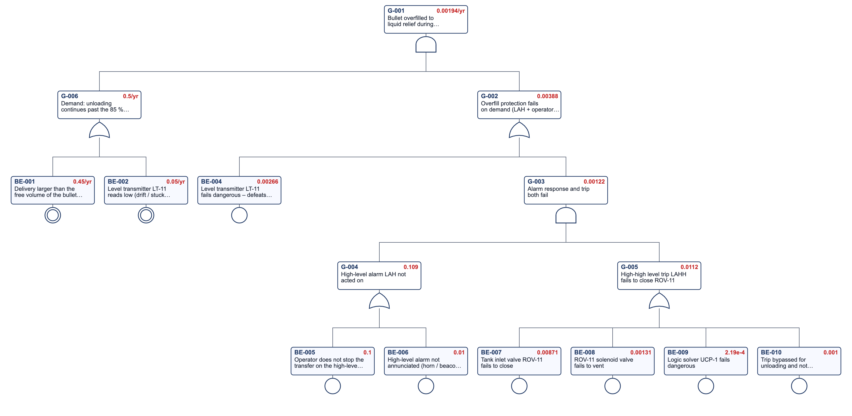
FT-PR-01 as drawn by the Fault Tree & PFD Calculator (red: time-averaged values).
Top-event frequency 1.9E-3 /yr. Gate values: G-001 1.9E-3; G-002 3.9E-3; G-003 1.2E-3; G-004 1.1E-1; G-005 1.1E-2; G-006 5.0E-1.
Event | Description | Fussell-Vesely | RAW
BE-001 | Delivery larger than the free volume of the bullet – ullage not checked | 0.900 | –
BE-004 | Level transmitter LT-11 fails dangerous – defeats both the alarm and the trip | 0.685 | 2.6E2
BE-005 | Operator does not stop the transfer on the high-level alarm | 0.286 | 3.6E0
BE-007 | Tank inlet valve ROV-11 fails to close | 0.243 | 2.9E1
BE-002 | Level transmitter LT-11 reads low (drift / stuck float) – operator unaware | 0.100 | –
BE-008 | ROV-11 solenoid valve fails to vent | 0.036 | 2.9E1

Event | Library item | Value | Status
BE-004 | Level transmitter, radar – λDU | 6.0E-7 /h | typical – verify
BE-005 | Operator response to an independent alarm, ≥ 10 min, simple documented action, clear indication | 1.0E-1 | checked – CCPS LOPA (2001), Table 6.5; CCPS Guidelines for Hazard Evaluation Procedures, 3rd ed., Table 7.4; CCPS Guidelines for Initiating Events and IPLs in LOPA (2015), Data Table 5.46
BE-006 | Alarm horn / beacon fails on demand | 1.0E-2 | typical – verify
BE-007 | Shutdown valve (ball / gate) with actuator – λDU | 2.0E-6 /h | typical – verify
BE-008 | Solenoid / pilot valve on an actuator – λDU | 3.0E-7 /h | typical – verify
BE-009 | Safety PLC, per function incl. I/O (certified) – λDU | 5.0E-8 /h | typical – verify

The protection PFDavg of 3.9E-3 is dominated by the shared level transmitter (BE-004). With an independent high-high switch (R-004) the alarm and the trip become two independent layers.

7.2 FT-PR-02 – Propane–air mixture enters the flammable range
Top event: the propane fraction in mixer MX-01 / surge tank ST-01 falls into the flammable range because propane is lost or air is over-supplied while blowers B-01/B-02 keep running, and both mixture protections fail. Protection (gate G-002) = low propane pressure trip PSLL-01 (stops the blowers, closes XV-01 / XV-02) AND the calorimeter trip AT-01. PSLL-01 cannot see a ratio-controller fault (BE-010). Gate G-002 is the mixture barrier of bow tie BT-PR-02 (threat T1). HAZOP N03-01; FMECA S03.
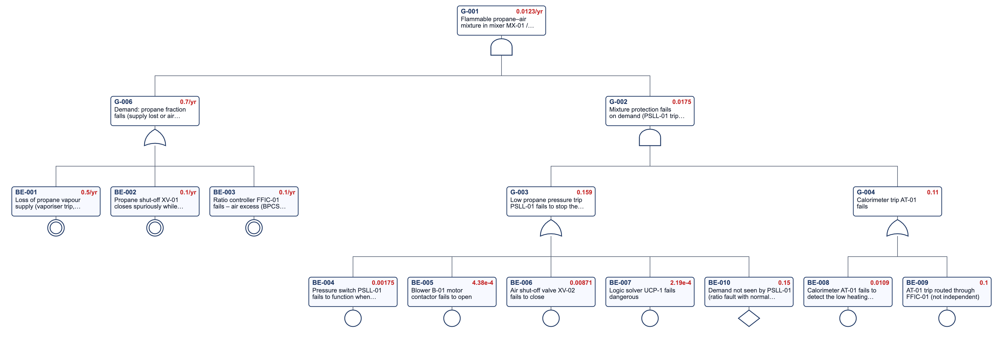
FT-PR-02 as drawn by the Fault Tree & PFD Calculator (red: time-averaged values).
Top-event frequency 1.2E-2 /yr. Gate values: G-001 1.2E-2; G-002 1.8E-2; G-003 1.6E-1; G-004 1.1E-1; G-006 7.0E-1.
Event | Description | Fussell-Vesely | RAW
BE-010 | Demand not seen by PSLL-01 (ratio fault with normal propane pressure) | 0.930 | 6.3E0
BE-009 | AT-01 trip routed through FFIC-01 (not independent) | 0.901 | 9.1E0
BE-001 | Loss of propane vapour supply (vaporiser trip, PCV-01 closes, header pressure low) | 0.714 | –
BE-002 | Propane shut-off XV-01 closes spuriously while the blowers run | 0.143 | –
BE-003 | Ratio controller FFIC-01 fails – air excess (BPCS loop failure) | 0.143 | –
BE-008 | Calorimeter AT-01 fails to detect the low heating value | 0.089 | 9.1E0

Event | Library item | Value | Status
BE-002 | Spurious trip of a SIF (process upset on restart) | 1.0E-1 /yr | typical – verify
BE-003 | BPCS instrument loop failure | 1.0E-1 /yr | checked – CCPS LOPA (2001), Table 5.1; CCPS Guidelines for Initiating Events and IPLs in LOPA (2015), Data Table 4.1
BE-004 | Electric pressure switch – fails to function when required | 4.0E-7 /h | checked – CCPS Guidelines for Process Equipment Reliability Data (1989), taxonomy 2.1.4.1.3 – mean
BE-005 | Motor starter / contactor (trip a pump) – λDU | 1.0E-7 /h | typical – verify
BE-006 | Shutdown valve (ball / gate) with actuator – λDU | 2.0E-6 /h | typical – verify
BE-007 | Safety PLC, per function incl. I/O (certified) – λDU | 5.0E-8 /h | typical – verify
BE-008 | Process analyser (O2, H2, H2S) used in a SIF – λDU | 5.0E-6 /h | typical – verify

The calorimeter trip routed through the ratio controller (BE-009) and the blind spot of PSLL-01 for ratio faults (BE-010) dominate; R-013 addresses both.

7.3 FT-PR-03 – Propane release at the unloading bay not isolated
Top event (gate G-001): a propane release at the unloading bay or tank farm is not isolated – neither gas detection GLD-1/2/3 (1oo3) through logic UCP-1 nor the operator's manual ESD-1 initiates, or ROV-1 / ROV-11 fail to close. PFDavg of G-001 is heading H2 of event tree ETA-PR-01 and the ESD barrier of bow tie BT-PR-01. HAZOP N01-09, N02-08; FMECA S01.
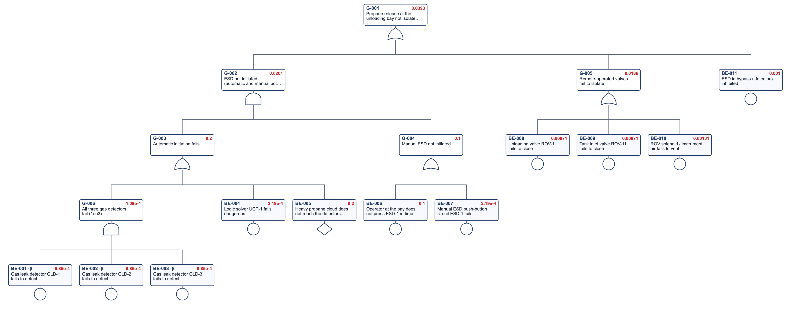
FT-PR-03 as drawn by the Fault Tree & PFD Calculator (red: time-averaged values).
Top-event PFDavg 3.9E-2. Gate values: G-001 3.9E-2; G-002 2.0E-2; G-003 2.0E-1; G-004 1.0E-1; G-005 1.9E-2; G-006 1.1E-4.
Event | Description | Fussell-Vesely | RAW
BE-005 | Heavy propane cloud does not reach the detectors (mounted too high) | 0.500 | 3.0E0
BE-006 | Operator at the bay does not press ESD-1 in time | 0.500 | 5.5E0
BE-008 | Unloading valve ROV-1 fails to close | 0.215 | 2.5E1
BE-009 | Tank inlet valve ROV-11 fails to close | 0.215 | 2.5E1
BE-010 | ROV solenoid / instrument air fails to vent | 0.032 | 2.5E1
BE-011 | ESD in bypass / detectors inhibited | 0.024 | 2.5E1

Event | Library item | Value | Status
BE-001 | Point gas detector, catalytic – λDU | 1.0E-6 /h | typical – verify
BE-002 | Point gas detector, catalytic – λDU | 1.0E-6 /h | typical – verify
BE-003 | Point gas detector, catalytic – λDU | 1.0E-6 /h | typical – verify
BE-004 | Safety PLC, per function incl. I/O (certified) – λDU | 5.0E-8 /h | typical – verify
BE-006 | Operator response to an independent alarm, ≥ 10 min, simple documented action, clear indication | 1.0E-1 | checked – CCPS LOPA (2001), Table 6.5; CCPS Guidelines for Hazard Evaluation Procedures, 3rd ed., Table 7.4; CCPS Guidelines for Initiating Events and IPLs in LOPA (2015), Data Table 5.46
BE-007 | Hard-wired relay logic, per function – λDU | 5.0E-8 /h | typical – verify
BE-008 | Shutdown valve (ball / gate) with actuator – λDU | 2.0E-6 /h | typical – verify
BE-009 | Shutdown valve (ball / gate) with actuator – λDU | 2.0E-6 /h | typical – verify
BE-010 | Solenoid / pilot valve on an actuator – λDU | 3.0E-7 /h | typical – verify

The heavy-gas detection coverage (BE-005) and the operator's manual ESD dominate the PFDavg of 3.9E-2.

8 Event tree analysis

8.1 ETA-PR-01 – Major propane release at the unloading bay or tank farm
Initiating event = top event of bow tie BT-PR-01, frequency 8.3E-3 /yr. H2 is linked to fault tree FT-PR-03 (gas detection & ESD). End-state frequencies are reproduced by the bow-tie consequences JET, BLEVE, FF and VCE. HAZOP N01-07, N01-09, N02-08. Illustrative probabilities.
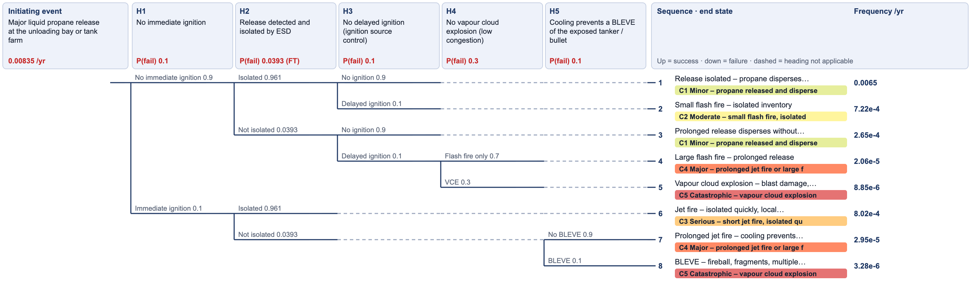
ETA-PR-01 as drawn by Event Tree Analysis.
Heading | Success / failure | P(failure) | Source
H1 No immediate ignition | No immediate ignition / Immediate ignition | 1.0E-1 | Large liquid LPG release, ignition at the source – illustrative; = BT-PR-01 'BLEVE' condition
H2 Release detected and isolated by ESD | Isolated / Not isolated | 3.9E-2 | PFDavg from fault tree FT-PR-03 gate G-001 = BT-PR-01 ESD barrier
H3 No delayed ignition (ignition source control) | No ignition / Delayed ignition | 1.0E-1 | Library ipl-ign-good (CCPS HEP Table 7.4) = BT-PR-01 barrier 'Ignition source control'
H4 No vapour cloud explosion (low congestion) | Flash fire only / VCE | 3.0E-1 | Fraction of delayed ignitions in congested areas (compressor house, pipe racks) – illustrative
H5 Cooling prevents a BLEVE of the exposed tanker / bullet | No BLEVE / BLEVE | 1.0E-1 | = BT-PR-01 barrier 'Sprinkler / deluge cooling' (R-009)

End state | Category | Frequency /yr
Release isolated – propane disperses without ignition | C1 – Minor – propane released and dispersed | 6.5E-3
Small flash fire – isolated inventory | C2 – Moderate – small flash fire, isolated inventory | 7.2E-4
Prolonged release disperses without ignition – area evacuated | C1 – Minor – propane released and dispersed | 2.7E-4
Large flash fire – prolonged release | C4 – Major – prolonged jet fire or large flash fire | 2.1E-5
Vapour cloud explosion – blast damage, multiple fatalities | C5 – Catastrophic – vapour cloud explosion or BLEVE, multiple fatalities | 8.8E-6
Jet fire – isolated quickly, local damage | C3 – Serious – short jet fire, isolated quickly | 8.0E-4
Prolonged jet fire – cooling prevents BLEVE | C4 – Major – prolonged jet fire or large flash fire | 2.9E-5
BLEVE – fireball, fragments, multiple fatalities | C5 – Catastrophic – vapour cloud explosion or BLEVE, multiple fatalities | 3.3E-6

Category | Frequency /yr | Target /yr | Meets target?
C1 Minor – propane released and dispersed | 6.8E-3 | – | Yes
C2 Moderate – small flash fire, isolated inventory | 7.2E-4 | 1 | Yes
C3 Serious – short jet fire, isolated quickly | 8.0E-4 | 0.1 | Yes
C4 Major – prolonged jet fire or large flash fire | 5.0E-5 | 0.01 | Yes
C5 Catastrophic – vapour cloud explosion or BLEVE, multiple fatalities | 1.2E-5 | 0.0001 | Yes

The vapour cloud explosion and BLEVE frequency of 1.2E-5 /yr meets the 1E-4 /yr target; the major-outcome frequency 5.0E-5 /yr meets the 1E-2 /yr target.

9 Bow tie analysis

9.1 BT-PR-01 – Loss of containment of propane at the unloading bay and storage
Threat T1 frequency = demand gate G-006 of fault tree FT-PR-01 with the overfill barrier = FT-PR-01 gate G-002, so its contribution equals the FT-PR-01 top event. The ESD barrier = FT-PR-03 gate G-001. The top-event frequency is the initiating frequency of event tree ETA-PR-01; consequences JET, BLEVE, FF and VCE reproduce its end states. HAZOP N01, N02; FMECA S01, S02. Illustrative data.
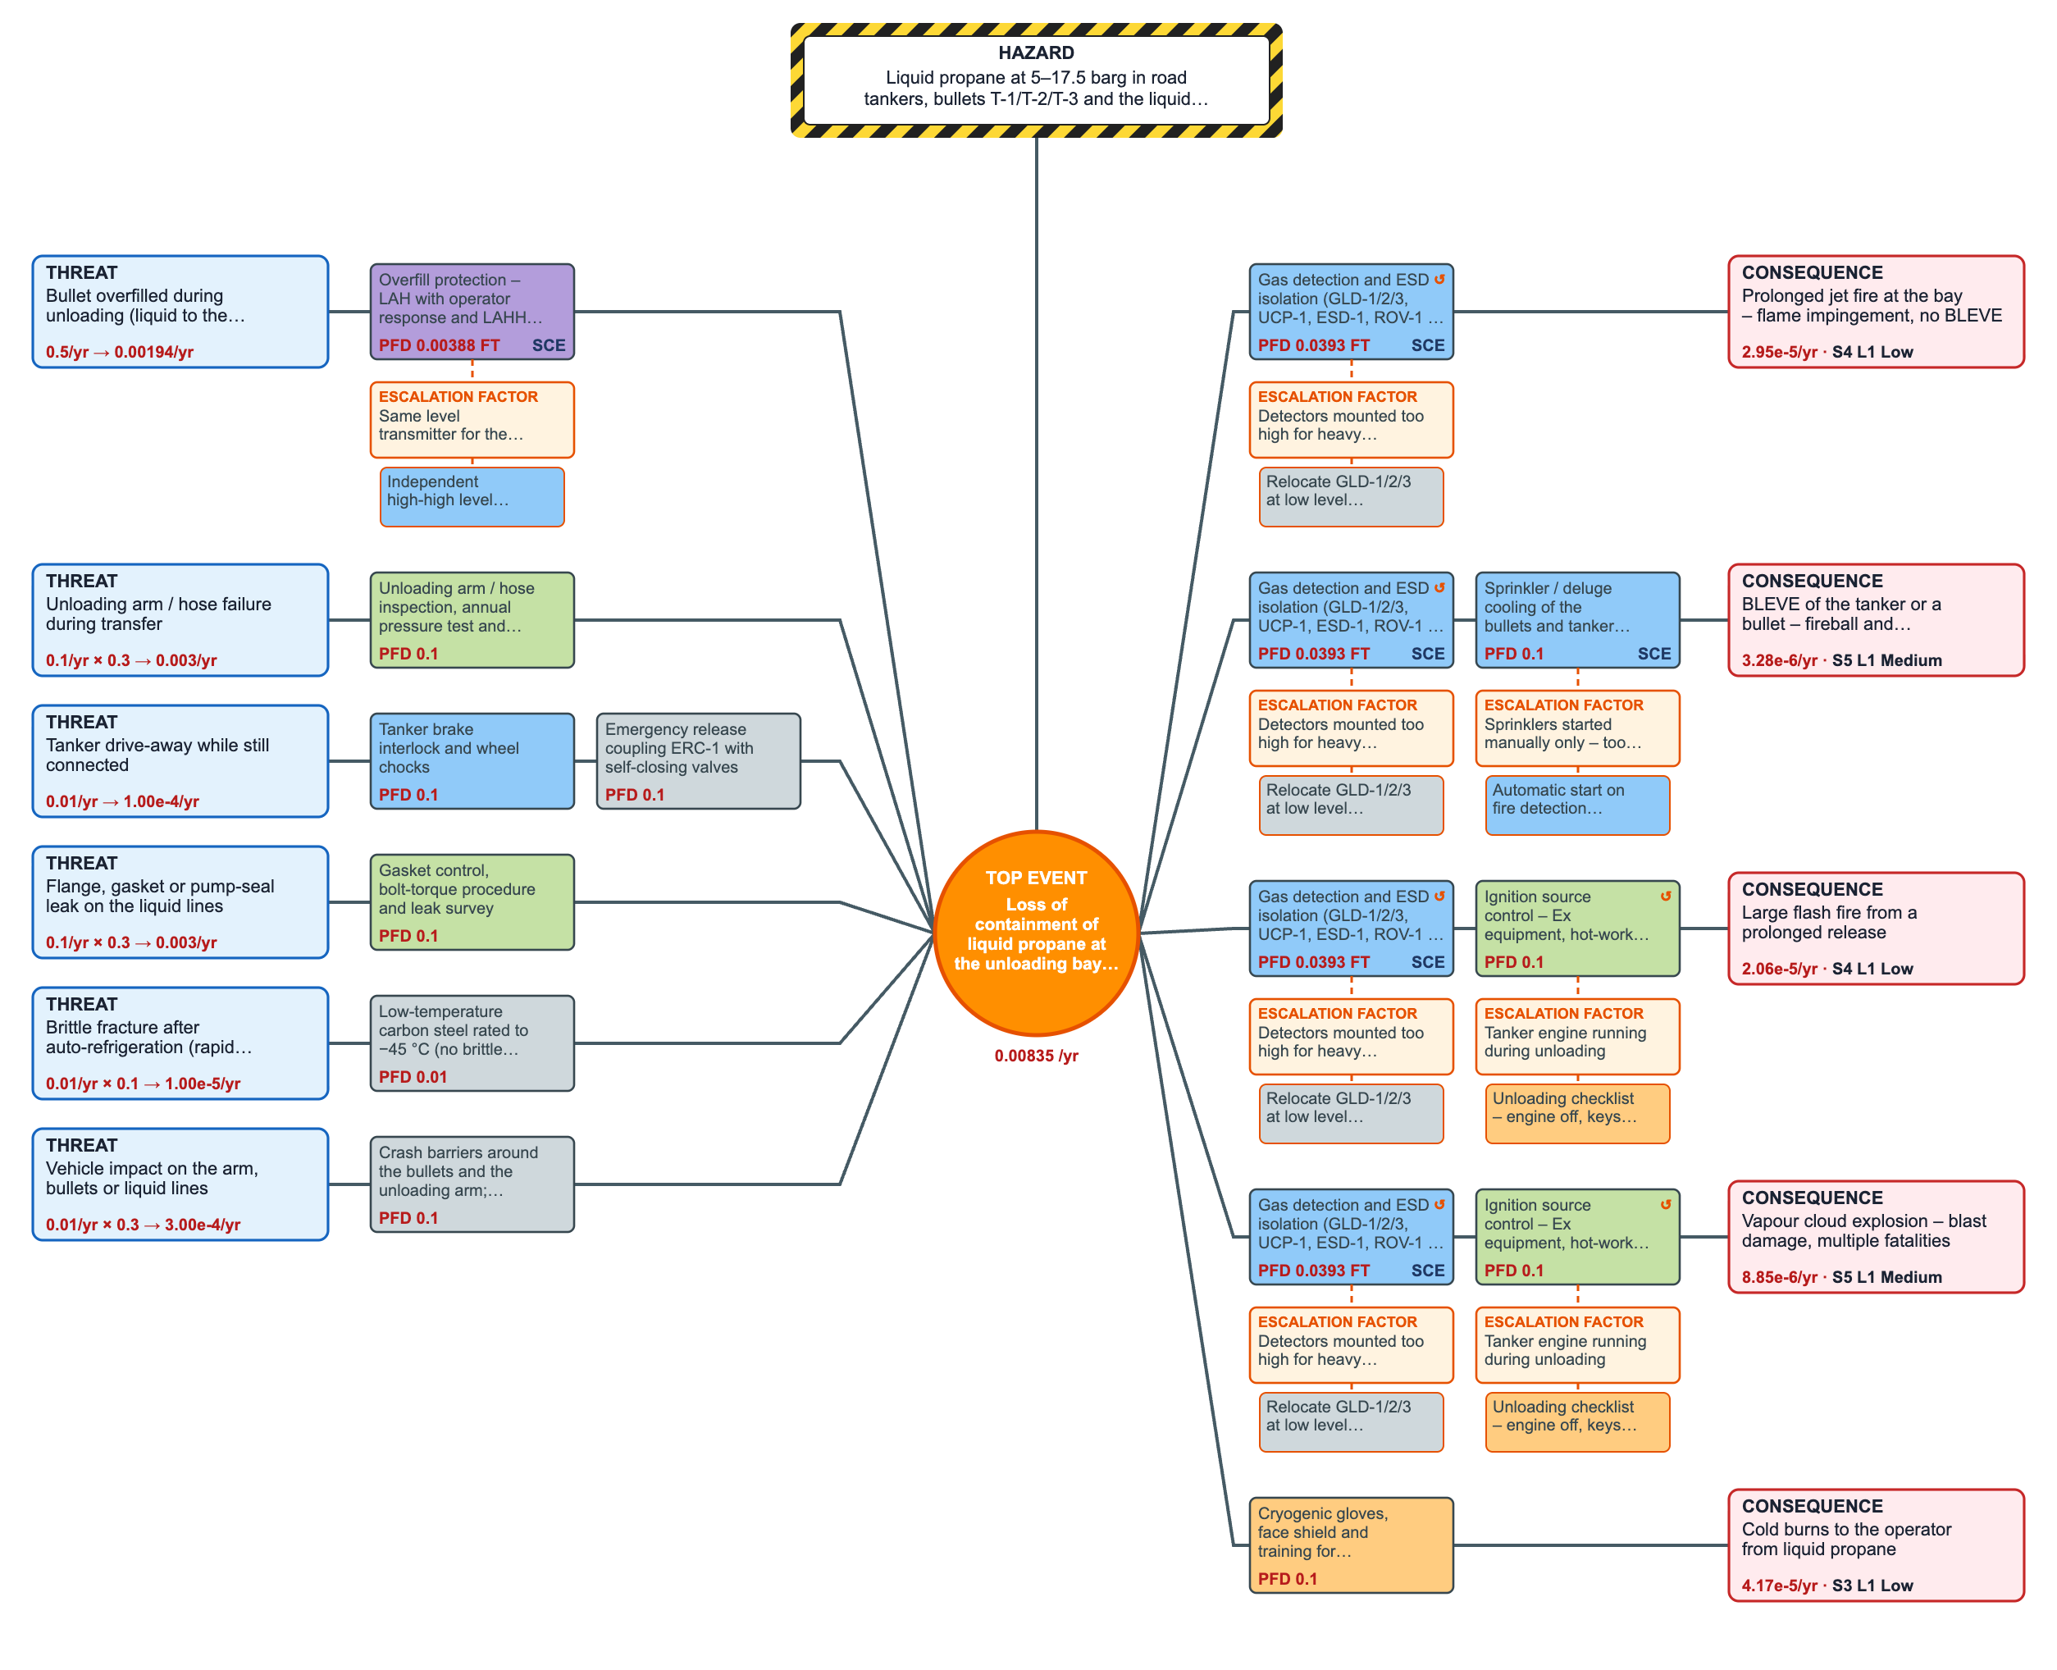
BT-PR-01 as drawn by Bow Tie Analysis.
Hazard: Liquid propane at 5–17.5 barg in road tankers, bullets T-1/T-2/T-3 and the liquid lines (extremely flammable, heavier-than-air vapour). Top event: Loss of containment of liquid propane at the unloading bay or tank farm – frequency 8.3E-3 /yr.
Threat | Frequency /yr | Condition | Barriers | Contribution /yr
Bullet overfilled during unloading (liquid to the relief valves) | 5.0E-1 | 1 | Overfill protection – LAH with operator response and LAHH trip closing ROV-11/21/31 | 1.9E-3
Unloading arm / hose failure during transfer | 1.0E-1 | 0.3 | Unloading arm / hose inspection, annual pressure test and pre-transfer leak test | 3.0E-3
Tanker drive-away while still connected | 1.0E-2 | 1 | Tanker brake interlock and wheel chocks  Emergency release coupling ERC-1 with self-closing valves | 1.0E-4
Flange, gasket or pump-seal leak on the liquid lines | 1.0E-1 | 0.3 | Gasket control, bolt-torque procedure and leak survey | 3.0E-3
Brittle fracture after auto-refrigeration (rapid depressurisation) | 1.0E-2 | 0.1 | Low-temperature carbon steel rated to −45 °C (no brittle fracture on auto-refrigeration) | 1.0E-5
Vehicle impact on the arm, bullets or liquid lines | 1.0E-2 | 0.3 | Crash barriers around the bullets and the unloading arm; vehicle-movement plan | 3.0E-4

Barrier | Type | PFD | Performance standard | Verification | Critical
Overfill protection – LAH with operator response and LAHH trip closing ROV-11/21/31 | Active human-hardware | 3.9E-3 | Unloading stopped before 85 % fill | Six-monthly trip test (R-004) | Yes
Unloading arm / hose inspection, annual pressure test and pre-transfer leak test | Continuous / procedural | 1.0E-1 | No hose fails in service | Inspection records
Tanker brake interlock and wheel chocks | Active hardware | 1.0E-1 | Tanker cannot move while connected | Monthly function check
Emergency release coupling ERC-1 with self-closing valves | Passive hardware | 1.0E-1 | Arm separates with both sides closed | Annual inspection
Gasket control, bolt-torque procedure and leak survey | Continuous / procedural | 1.0E-1 | Joints made to procedure | Annual leak survey
Low-temperature carbon steel rated to −45 °C (no brittle fracture on auto-refrigeration) | Passive hardware | 1.0E-2 | Material suitable for −45 °C | Material certificates; R-007 verification
Crash barriers around the bullets and the unloading arm; vehicle-movement plan | Passive hardware | 1.0E-1 | No vehicle can strike the equipment | Annual inspection
Gas detection and ESD isolation (GLD-1/2/3, UCP-1, ESD-1, ROV-1 / ROV-11) | Active hardware | 3.9E-2 | Release detected and isolated within 1 minute | Quarterly detector bump tests; annual ROV full-stroke tests | Yes
Ignition source control – Ex equipment, hot-work permits, vehicle control | Continuous / procedural | 1.0E-1 | No ignition source in the zoned area | Ex inspection; PTW audits
Sprinkler / deluge cooling of the bullets and tanker prevents a BLEVE | Active hardware | 1.0E-1 | 10 l/min/m2 on exposed shells within 2 minutes | Annual flow test (R-009) | Yes
Cryogenic gloves, face shield and training for connecting / disconnecting | Active human | 1.0E-1 | No skin contact with liquid propane | Supervision

Consequence | Condition | Barriers | Residual /yr | Risk rank
Prolonged jet fire at the bay – flame impingement, no BLEVE | 0.09 | Gas detection and ESD isolation (GLD-1/2/3, UCP-1, ESD-1, ROV-1 / ROV-11) | 2.9E-5 | Low
BLEVE of the tanker or a bullet – fireball and fragments | 0.1 | Gas detection and ESD isolation (GLD-1/2/3, UCP-1, ESD-1, ROV-1 / ROV-11)  Sprinkler / deluge cooling of the bullets and tanker prevents a BLEVE | 3.3E-6 | Medium
Large flash fire from a prolonged release | 0.63 | Gas detection and ESD isolation (GLD-1/2/3, UCP-1, ESD-1, ROV-1 / ROV-11)  Ignition source control – Ex equipment, hot-work permits, vehicle control | 2.1E-5 | Low
Vapour cloud explosion – blast damage, multiple fatalities | 0.27 | Gas detection and ESD isolation (GLD-1/2/3, UCP-1, ESD-1, ROV-1 / ROV-11)  Ignition source control – Ex equipment, hot-work permits, vehicle control | 8.8E-6 | Medium
Cold burns to the operator from liquid propane | 0.05 | Cryogenic gloves, face shield and training for connecting / disconnecting | 4.2E-5 | Low

The overfill threat (T1) and hose failure (T2) dominate the top event; overfill is the threat the source study understated.

9.2 BT-PR-02 – Ignition of a propane–air mixture inside the dilution system
Threat T1 = flammable mixture (fault tree FT-PR-02 demand gate G-006) with the mixture-protection barrier = FT-PR-02 gate G-002, and a conditional probability of ignition (flashback at a burner) of 0.5 – its contribution is the FT-PR-02 top event x 0.5. HAZOP N03; FMECA S03. Illustrative data.
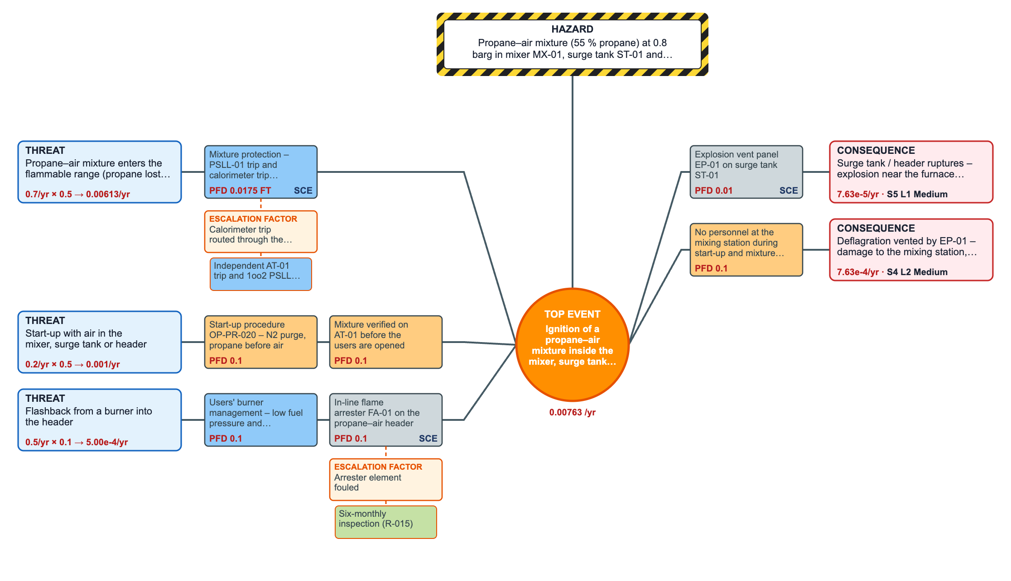
BT-PR-02 as drawn by Bow Tie Analysis.
Hazard: Propane–air mixture (55 % propane) at 0.8 barg in mixer MX-01, surge tank ST-01 and the header to the burners. Top event: Ignition of a propane–air mixture inside the mixer, surge tank or header – frequency 7.6E-3 /yr.
Threat | Frequency /yr | Condition | Barriers | Contribution /yr
Propane–air mixture enters the flammable range (propane lost, air continues) | 7.0E-1 | 0.5 | Mixture protection – PSLL-01 trip and calorimeter trip AT-01 | 6.1E-3
Start-up with air in the mixer, surge tank or header | 2.0E-1 | 0.5 | Start-up procedure OP-PR-020 – N2 purge, propane before air  Mixture verified on AT-01 before the users are opened | 1.0E-3
Flashback from a burner into the header | 5.0E-1 | 0.1 | Users' burner management – low fuel pressure and flame-failure trips  In-line flame arrester FA-01 on the propane–air header | 5.0E-4

Barrier | Type | PFD | Performance standard | Verification | Critical
Mixture protection – PSLL-01 trip and calorimeter trip AT-01 | Active hardware | 1.8E-2 | Air stopped before the mixture reaches 15 % propane | Annual trip tests | Yes
Start-up procedure OP-PR-020 – N2 purge, propane before air | Active human | 1.0E-1 | No air in the system at start-up | Observation audits
Mixture verified on AT-01 before the users are opened | Active human | 1.0E-1 | Users opened only with mixture in specification | Log check
In-line flame arrester FA-01 on the propane–air header | Passive hardware | 1.0E-1 | Flame stopped at FA-01 | Six-monthly inspection (R-015) | Yes
Explosion vent panel EP-01 on surge tank ST-01 | Passive hardware | 1.0E-2 | Panel opens before ST-01 ruptures | Annual inspection | Yes
Users' burner management – low fuel pressure and flame-failure trips | Active hardware | 1.0E-1 | Burners trip before flashback | Annual BMS test
No personnel at the mixing station during start-up and mixture changes | Active human | 1.0E-1 | Area clear during start-up | Supervision

Consequence | Condition | Barriers | Residual /yr | Risk rank
Surge tank / header ruptures – explosion near the furnace building | 1 | Explosion vent panel EP-01 on surge tank ST-01 | 7.6E-5 | Medium
Deflagration vented by EP-01 – damage to the mixing station, outage | 1 | No personnel at the mixing station during start-up and mixture changes | 7.6E-4 | Medium

The internal-explosion frequency 7.6E-5 /yr is just below the 1E-4 /yr target – with little margin, so R-013 and R-014 are High priority.

10 How the tools link – cross-reference
The cross-link tests (section 11) prove each of these links on the files themselves.
From | To | What is shared
HAZID HZD-02, HZD-12 | HAZOP N01-06, N03-01 | Hazards sent to HAZOP nodes
HAZOP N01-06 | FT-PR-01 | Overfill scenario; likelihood after safeguards from the FT top event
HAZOP N03-01 | FT-PR-02 | Flammable-mixture scenario; likelihood from the FT top event
FT-PR-01 G-002 | BT-PR-01 barrier OVERFILL | Overfill protection PFDavg (live link)
FT-PR-01 G-006 | BT-PR-01 threat T1 | Overfill demand frequency
FT-PR-03 G-001 | ETA-PR-01 H2 and BT-PR-01 barrier ESD | ESD PFDavg (live links)
BT-PR-01 top event | ETA-PR-01 initiating event | Release frequency
ETA-PR-01 end states | BT-PR-01 consequences JET, BLEVE, FF, VCE | Same frequencies
FT-PR-02 G-002 / G-006 | BT-PR-02 barrier MIXPROT / threat T1 | Mixture protection and demand
FMECA S01–S03 | HAZOP N01–N03, FT events | Same tags and failure modes

10.1 Key results
Value | Result
Bullet overfill frequency /yr (FT-PR-01) | 1.9E-3
Overfill protection PFDavg | 3.9E-3
Overfill demand /yr | 5.0E-1
Flammable mixture /yr (FT-PR-02) | 1.2E-2
Mixture protection PFDavg | 1.8E-2
Mixture demand /yr | 7.0E-1
Gas detection & ESD PFDavg (FT-PR-03) | 3.9E-2
Gas detection & ESD RRF | 2.5E1
Loss of containment /yr (BT-PR-01) | 8.3E-3
BT1_JET | 2.9E-5
BT1_BLEVE | 3.3E-6
BT1_FF | 2.1E-5
BT1_VCE | 8.8E-6
BT1_COLD | 4.2E-5
Ignition in the dilution system /yr (BT-PR-02) | 7.6E-3
Internal explosion /yr | 7.6E-5
BT2_DEFL | 7.6E-4
Catastrophic (VCE / BLEVE) /yr (ETA-PR-01) | 1.2E-5
Major /yr | 5.0E-5
Serious /yr | 8.0E-4
Moderate /yr | 7.2E-4

11 Verification of the example (cross-link tests)
Every study file was re-opened in its toolkit app and recalculated by the app's own engine; the workbooks were recalculated in LibreOffice. The automated test (test_example.py) ran 475 checks: 475 passed, 0 failed.
Check group | Passed | Failed
A. Apps | 30 | 0
B. Numbers | 64 | 0
C. References | 122 | 0
D. Tags | 37 | 0
E. Workbooks | 66 | 0
G. HAZID | 74 | 0
W. What-If | 35 | 0
F. Report | 47 | 0

12 Recommendations register
No. | Recommendation | Responsible | Priority | HAZOP refs
R-001 | Provide copper / aluminium / G.I. jumper strips for electrical continuity at every flange of the unloading line, check the resistance of all earthing strips and pits and keep a record; add an earth bonding interlock (EBI-1) so the compressors cannot start without a verified tanker earth (source recommendation no. 1, completed). | Electrical engineer | High | N01-03
R-002 | Provide a diesel generator for back-up power to the propane storage system so that a power failure during unloading or supply leaves the system in a controlled state (source recommendation no. 2). Confirm that every ROV fails closed and that UCP-1 and the gas detection are on UPS-1. | Electrical engineer | Medium | N01-12, N02-10, N03-09
R-003 | Add the bullet relief valves PSV-11/21/31 and PRV-01 to the statutory inspection schedule with a 2-yearly bench-test interval (source remark, made a recommendation). | Mechanical engineer | High | N01-02, N01-04
R-004 | Make the overfill trip independent of the level gauge used for control: fit an independent high-high level switch on each bullet acting on ROV-11/21/31, and proof-test the trip every 6 months. Fault tree FT-PR-01 gives an overfill frequency of 1.9E-3 /yr with the protection PFDavg 3.9E-3. | Instrument engineer | High | N01-06
R-005 | Add a written ullage calculation to the unloading checklist (volume in the bullet + delivery ≤ 85 %), signed before the compressor is started. | Utilities superintendent | High | N01-06, N01-11, N02-09
R-006 | Fit an emergency release coupling ERC-1 and a tanker brake interlock at the unloading bay; drive-away during unloading is not covered by the source safeguards. | Mechanical engineer | High | N01-10
R-007 | Confirm that the bullets, the liquid lines and the unloading arm are rated for −45 °C (auto-refrigeration of propane on rapid depressurisation); the source worksheet recorded 'Lower temperature – no issue'. | Process engineer | High | N01-08
R-008 | Verify the gas detection and ESD function against the required risk reduction: fault tree FT-PR-03 gives PFDavg 3.9E-2; relocate GLD-1/2/3 at low level (propane vapour is heavier than air) and add a detector at the compressor house. | Instrument engineer | High | N01-09, N02-08, N03-08
R-009 | Check the bullet sprinkler / deluge coverage and density against the fire-case relief study and add automatic start on fire detection at the unloading bay (BLEVE prevention); test annually. | Fire officer | High | N01-07
R-010 | Fit a low-suction-pressure trip and seal-pot alarm on P-01/P-02; replace single seals with double mechanical seals. | Mechanical engineer | Medium | N02-02, N02-08
R-011 | Provide a second, independent liquid carry-over protection on each vaporiser (high-level trip LSH-01 in addition to TSL-01) and test both every 6 months. | Instrument engineer | High | N02-04, N02-05
R-012 | Confirm the set-point staggering of PCV-01 (1.5 barg), SSV-01 (2.5 barg) and PSV-03 (3.0 barg) against the vapour header design pressure (3.5 barg). | Process engineer | Medium | N02-03
R-013 | Upgrade the propane–air mixture protection: make the calorimeter AT-01 trip independent of FFIC-01 and add a second low propane pressure switch (1oo2). Fault tree FT-PR-02 gives a flammable-mixture frequency of 1.2E-2 /yr (protection PFDavg 1.8E-2); bow tie BT-PR-02 internal explosion 7.6E-5 /yr. | Instrument engineer | High | N03-01, N03-02, N03-05
R-014 | Rewrite the mixing-station start-up procedure OP-PR-020: N2 purge, propane established before air, AT-01 reading verified before the users are opened; add a start-permissive interlock. | Utilities superintendent | High | N03-06, N03-09
R-015 | Inspect flame arrester FA-01 every 6 months (fouling) and confirm it is rated for the propane–air mixture and pipe length (in-line deflagration arrester). | Mechanical engineer | Medium | N03-07
R-016 | Introduce a vehicle-movement plan for the unloading bay (no other traffic during unloading, crash barriers around the bullets and the arm). | Area owner | Medium | N01-01
R-017 | Train LPG operators on the response to a release (ESD, evacuation upwind, no attempt to stop a burning leak, cooling of exposed vessels) with a drill twice a year; event tree ETA-PR-01 gives 1.2E-5 /yr for a vapour cloud explosion or BLEVE. | HSE / process safety | High | N01-07

13 Conclusions
- The source worksheet's weakest entries were the ones with the largest hazards: overfill, low temperature and the fire case. Completing them changed the risk picture of node 301.
- Bullet overfill (1.9E-3 /yr) is the main threat to containment; an independent high-high level trip (R-004) and a written ullage check (R-005) are the priority actions.
- In the dilution system, a flammable propane–air mixture (1.2E-2 /yr) gives an internal-explosion frequency of 7.6E-5 /yr – close to the 1E-4 /yr target; R-013 and R-014 restore the margin.
- The release outcomes meet their targets (VCE / BLEVE 1.2E-5 /yr) as long as the ESD (PFDavg 3.9E-2) and the sprinkler cooling perform as assumed – both depend on R-008 and R-009.

14 Limitations
- All design data and failure data are illustrative. Library values marked 'typical' must be verified against the edition used; site and vendor data take precedence.
- Consequence severities are judgement; no dispersion, fire or explosion modelling was done.
- Nodes 302 and 303 were developed for this example and are not part of the source study.

